# Технологическая карта

**урока английского языка в 8м классе Тема:** «Здоровое/нездоровое питание».

**Тип урока:** обобщающий по теме.

**Средства:** УМК «Spotlight-8»

**Цель урока:** обобщение и систематизация знаний обучающихся по теме

«Здоровое и нездоровое питание».

# Задачи урока:

*Образовательные:*

* Углубление и расширение знаний обучающихся по теме «Здоровое и нездоровое питание».
* Активизация лексического материала по теме «Здоровое и нездоровое питание».
* Умение воспринимать на слух и понимать краткие сообщения.
* Умение извлекать из текста нужную информацию.

*Развивающие:*

* Развитие языковых, познавательных способностей обучающихся, готовности к общению во всех сферах бытия.
* Развитие познавательного интереса у обучающихся, умения обобщать, анализировать полученную информацию.
* Развитие памяти, речи, логического мышления.

*Воспитательные:*

* Формирование ценностного отношения обучающихся к здоровью и здоровому образу питания.
* Формирование потребности употреблять здоровую пищу.

**Межпредметные связи:** В ходе подготовки к уроку учащиеся используют информацию, полученную ими на уроках английского языка, биологии и ОБЖ.

# ХОД УРОКА

# Речевая зарядка.

* 1. How many times a day do you have a meal?
  2. Which meal is the most important?
  3. Do you skip a meal?
  4. What do you like to eat?
  5. What is your favorite food?
  6. Did you eat any fruit and vegetables yesterday (including potatoes)?
  7. How many times a week do you eat fruit and vegetables?
  8. What have you had for breakfast today?

# II Основная часть

1. **Phonetics.**

First of all I want you to remember the English sounds and words on the topic “Food”.

[p] – plump, pepper, apple, pear

[t] – nut, carrot, plate

[tS] – cherry, cheese, chocolate

[d3] – jam, vegetables, juice, cabbage [i:] – tea, pea, sweet, meat

[ei] – cake, grapes, cocktail

1. **Vocabulary.** At first we should revise some words on our topic.
2. **Food.** Look at the pictures, choose the right word and say if you like this food or not? (*Слайд 2 с изображением продуктов, учащиеся подбирают слова к картинкам и высказывают свое отношение к продуктам).*
3. **Healthy and Unhealthy food:** Every day we eat some food but we don’t always think whether it is healthy or unhealthy. It is time for us to think about it! Now, children, share your ideas what is healthy food and what is unhealthy food? You see two groups named “healthy breakfast” and “unhealthy breakfast”. Sort out these items of food to the right columns. *(учащиеся распределяют продукты на две группы).*

I hope you usually eat healthy breakfast.

1. **Reading.** To be active and healthy we should eat different types of food. Are there any rules of healthy eating? Do you know any rules? How much should we eat? To find out the answers we are going to read a short text and find the most important rules of good diet. Scan the text and tick the most important rules of balanced diet*.*

# Balanced diet

You have probably heard or read quite a lot about "healthy eating": don't eat too much of this ... eat a bit more of that. But there are really only two important rules for healthy eating.

Firstly, eat a good variety of different sort of food. The best way to be sure that you eat a good variety is to choose from the main groups of food and to have them regularly in your diet:

* 1. Fresh fruit, vegetables and salad.
  2. Cereals: rise, pasta, bread and other grains.
  3. Protein foods: meat, chicken, fish, eggs, beans or nuts.
  4. Dairy products: cheese, yogurt, milk.

The second thing to remember is the quantity of food that you eat. Don't eat too much. Be especially careful with some foods - try not to eat too much sugar or fat or salt, for example.

Follow these two rules for a healthy, balanced diet.

**Teacher:** How many rules have you found?

**Teacher:** What is the first rule?

**Teacher:** What does it mean a good variety of different sorts of food?

1. **The Food Pyramid**. Teacher: What can help us? Look at this picture *(слайд 3).* Have you seen this picture before at nursery or primary school? How is it called? What do you think it tells us?

The Food Guide Pyramid is a practical tool to help you make food choices. Using the Pyramid helps you to eat a variety of foods daily so that you can get the nutrients you need. The Food Pyramid shows the five food groups. What are they? Now look at the blackboard. Here we can see a pyramid and on the right there are the names of the 5 food groups. We are going to watch a video (видео «Food Pyramid» на сайте Youtube. Watch it very carefully and complete this food pyramid with suitable items that come together *(слайд 4 Пустая пищевая пирамида).*

Ребята, добрый день! Прочитайте и переведите текст! Составьте пирамиду здорового питания с использованием изученной лексики по теме!

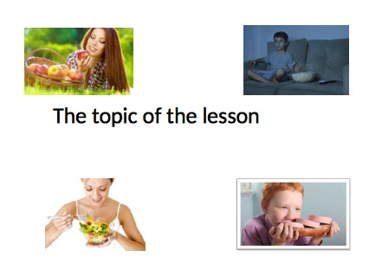

Слайд 2

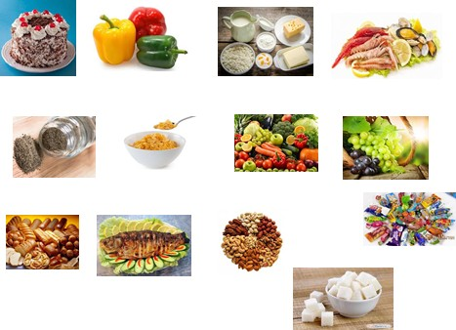

Слайд 3

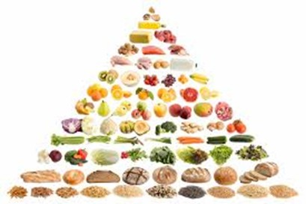

Слайд 4

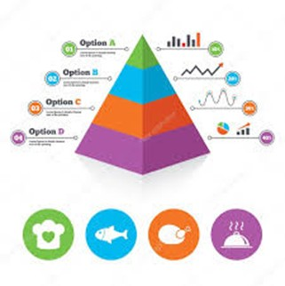

Слайд 5

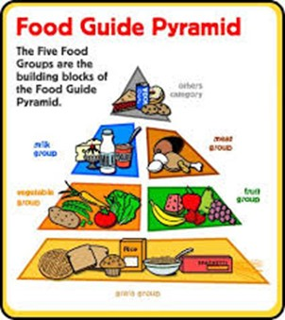

Слайд 6

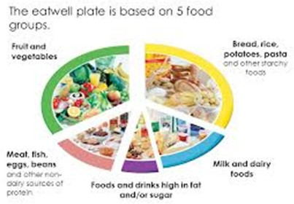

Слайд 7

